**SQL PROJECT - PIZZA SALES**

**A . KPI’s**

**1. Total Revenue:**

SELECT SUM(total_price) AS Total_Revenue FROM pizza_sales

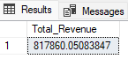

**2. Average Order Value**

SELECT (SUM(total_price) / COUNT(DISTINCT order_id)) AS Avg_order_Value FROM pizza_sales

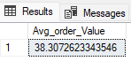

**3. Total Pizzas Sold**

SELECT SUM(quantity) AS Total_pizza_sold FROM pizza_sales



**4. Total Orders**

SELECT COUNT(DISTINCT order_id) AS Total_Orders FROM pizza_sales

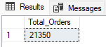

**5. Average Pizzas Per Order**

SELECT CAST (CAST(SUM(quantity) AS DECIMAl (10,2)) / CAST (COUNT(DISTINCT order_id) AS DECIMAL(10,2)) AS DECIMAL(10,2)) AS Avg_Pizzas_per_order FROM pizza_sales

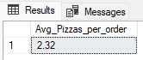

**B. Daily Trend for Total Orders**

SELECT DATENAME(DW, order_date) AS order_day, COUNT(DISTINCT order_id) AS total_orders

FROM pizza_sales

GROUP BY DATENAME(DW, order_date)

ORDER BY total_orders DESC

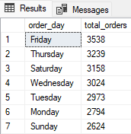

**C. Monthly Trend for Orders**

SELECT DATENAME(MONTH, order_date) AS Month_Name, COUNT(DISTINCT order_id) AS Total_orders

FROM pizza_sales

GROUP BY DATENAME(MONTH, order_date)

ORDER BY Total_orders DESC

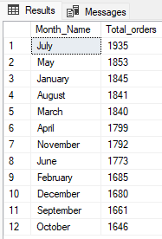

**D. % of Sales by Pizza Category**

SELECT pizza_category,CAST(sum(total_price) AS DECIMAL (10,2)) AS Total_revenue,CAST(sum(total_price)*100 / (SELECT SUM(total_price) from pizza_sales) AS DECIMAL(10,2)) AS PCT_Sales

from pizza_sales

GROUP BY pizza_category

ORDER BY PCT_Sales DESC

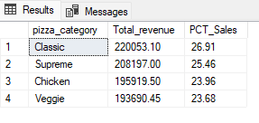

**E. % of Sales by Pizza Size**

SELECT pizza_size,CAST(sum(total_price) AS DECIMAL (10,2)) AS Total_revenue,CAST(sum(total_price)*100 / (SELECT SUM(total_price) from pizza_sales) AS DECIMAL(10,2)) AS PCT_Sales

from pizza_sales

GROUP BY pizza_size

ORDER BY PCT_Sales DESC

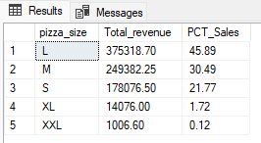

**F. Total Pizzas Sold by Pizza Category**

SELECT pizza_category,sum(quantity) AS Total_Quantity_Sold

FROM pizza_sales

GROUP BY pizza_category

ORDER BY Total_Quantity_Sold DESC

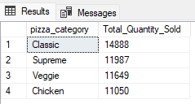

**G. Top 5 Pizzas by Revenue**

SELECT TOP 5 pizza_name,sum(total_price) AS Total_revenue

FROM pizza_sales

GROUP BY pizza_name

ORDER BY Total_revenue DESC

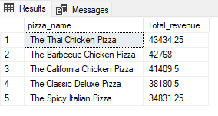

**H. Bottom 5 Pizzas by Revenue**

SELECT TOP 5 pizza_name,CAST(sum(total_price) AS DECIMAL(10,2)) AS Total_revenue

FROM pizza_sales

GROUP BY pizza_name

ORDER BY Total_revenue ASC

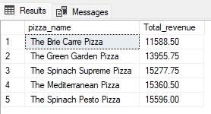

**I. Top 5 Pizzas by Quantity**

SELECT TOP 5 pizza_name,sum(quantity) AS Total_Pizza_Sold

FROM pizza_sales

GROUP BY pizza_name

ORDER BY Total_Pizza_Sold DESC

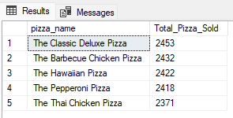

**J. Bottom 5 Pizzas by Quantity**

SELECT TOP 5 pizza_name,sum(quantity) AS Total_Pizza_Sold

FROM pizza_sales

GROUP BY pizza_name

ORDER BY Total_Pizza_Sold ASC

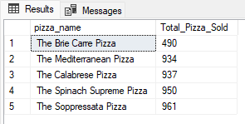

**K. Top 5 Pizzas by Total Orders**

SELECT TOP 5 pizza_name,COUNT(DISTINCT order_id) AS Total_Orders

FROM pizza_sales

GROUP BY pizza_name

ORDER BY Total_Orders DESC

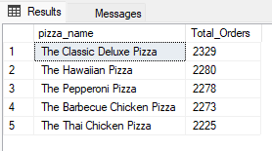

**L. Borrom 5 Pizzas by Total Orders**

SELECT TOP 5 pizza_name,COUNT(DISTINCT order_id) AS Total_Orders

FROM pizza_sales

GROUP BY pizza_name

ORDER BY Total_Orders ASC

